**Topics: Descriptive Statistics and Probability**

1. Look at the data given below. Plot the data, find the outliers and find out $μ, σ, σ^{2}$

|  |  |
| --- | --- |
| **Name of company** | **Measure X** |
| Allied Signal | 24.23% |
| Bankers Trust | 25.53% |
| General Mills | 25.41% |
| ITT Industries | 24.14% |
| J.P.Morgan & Co. | 29.62% |
| Lehman Brothers | 28.25% |
| Marriott | 25.81% |
| MCI | 24.39% |
| Merrill Lynch | 40.26% |
| Microsoft | 32.95% |
| Morgamean(n Stanley | 91.36% |
| Sun Microsystems | 25.99% |
| Travelers | 39.42% |
| US Airways | 26.71% |
| Warner-Lambert | 35.00% |

**Answer:**

**Code :**

**import pandas as pd**

**import seaborn as sns**

**import matplotlib.pyplot as plt**

**data=pd.Series([24.23,25.53,25.41,24.14,29.62,28.25,25.81,24.39,40.26,32.95,91.36,25.99,39.42,26.71,35.00])**

**names=["Allied Signal","Bankers Trust","General Mills","ITT Industries","J.P.Morgan & Co.","Lehman Brothers","Marriott","MCI","Merrill Lynch","Microsoft","Morgan Stanley","Sun Microsystems","Travelers","US Airways","Warner-Lambert"]**

**%matplotlib inline**

**fig=plt.figure(figsize=(8,8))**

**plt.pie(data,labels=names,autopct='%1.2f%%')**

**plt.show()**

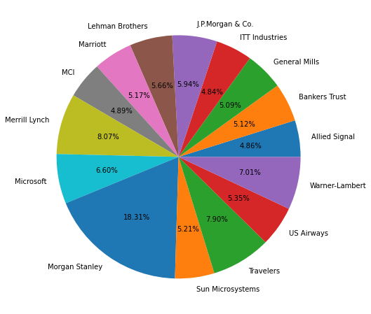

**sns.boxplot(data)**

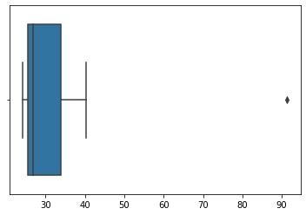

**round(data.mean(),4)**

**33.2713**

**round(data.std(),4)**

**16.9454**

**round(data.var(),4)**

**287.1466**



Answer the following three questions based on the box-plot above.

1. What is inter-quartile range of this dataset? (please approximate the numbers) In one line, explain what this value implies.

**Here clearly 25 is the outlier.**

**Median = 7**

**1st quartile = 5**

**2nd quartile = 12**

**IQR = (12-5) = 7**

**IQR tells us the range of the middle half of the data.**

1. What can we say about the skewness of this dataset?

**Positively skewed.**

1. If it was found that the data point with the value 25 is actually 2.5, how would the new box-plot be affected?

**In that case there would have been no outliers, and it might have affected in the values of mean and median slightly. The boxplot might have moved towards right slightly.**



Answer the following three questions based on the histogram above.

1. Where would the mode of this dataset lie?

**Between 5 – 8 (Most frequent data)**

1. Comment on the skewness of the dataset.

**It is positively skewed.**

1. Suppose that the above histogram and the box-plot in question 2 are plotted for the same dataset. Explain how these graphs complement each other in providing information about any dataset.

**By comparing both of them it is very clear that the data would be positively skewed. Also, would help us finding mean, mode value.**

1. AT&T was running commercials in 1990 aimed at luring back customers who had switched to one of the other long-distance phone service providers. One such commercial shows a businessman trying to reach Phoenix and mistakenly getting Fiji, where a half-naked native on a beach responds incomprehensibly in Polynesian. When asked about this advertisement, AT&T admitted that the portrayed incident did not actually take place but added that this was an enactment of something that “could happen.” Suppose that one in 200 long-distance telephone calls is misdirected. What is the probability that at least one in five attempted telephone calls reaches the wrong number? (Assume independence of attempts.)

**Answer:**

**Probability of call getting misdirected = (1/200)**

**Hence probability of call not getting misdirected = 1-(1/200) = 199/200**

**Number of phone calls attempted = 5**

**Therefore, probability that at least one in 5 attempted call reaches the wrong number is:**

**=1-(199/200) ^5**

**= 0.025**

1. Returns on a certain business venture, to the nearest $1,000, are known to follow the following probability distribution

|  |  |
| --- | --- |
| x | P(x) |
| -2,000 | 0.1 |
| -1,000 | 0.1 |
| 0 | 0.2 |
| 1000 | 0.2 |
| 2000 | 0.3 |
| 3000 | 0.1 |

1. What is the most likely monetary outcome of the business venture?

**Here the highest probability is for 2000.**

1. Is the venture likely to be successful? Explain

**Yes, because the total earnings of the venture is positive in value i.e 800 and highest probability of earning is 2000.**

1. What is the long-term average earning of business ventures of this kind? Explain



800

1. What is the good measure of the risk involved in a venture of this kind? Compute this measure

